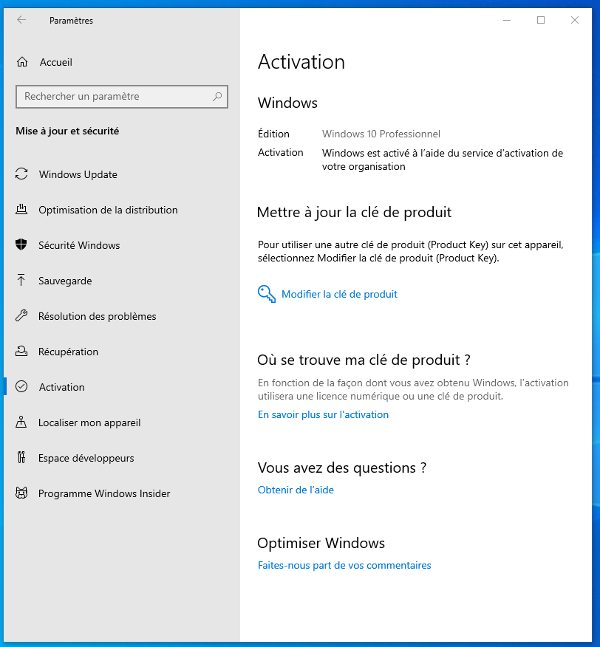

slmgr/xpr

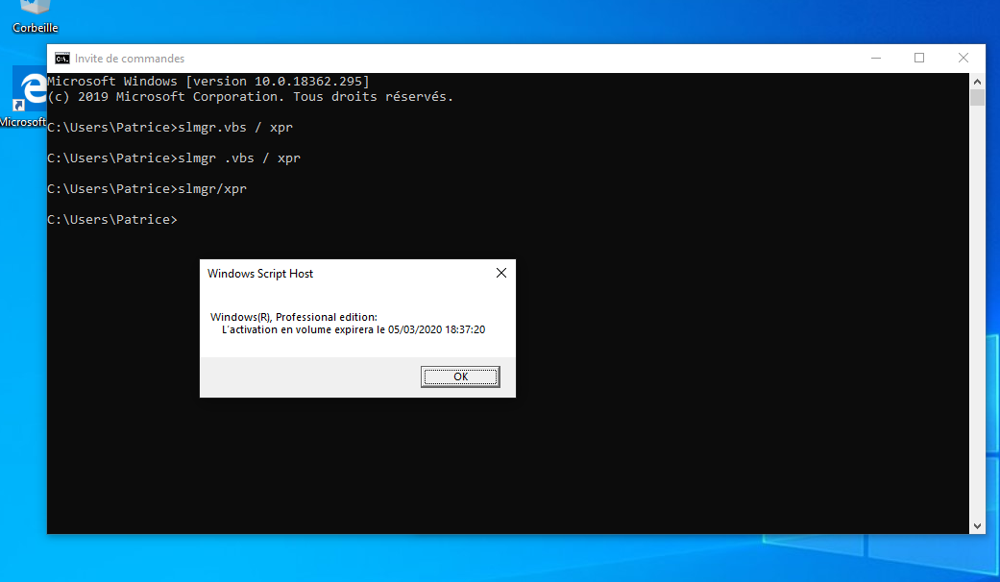

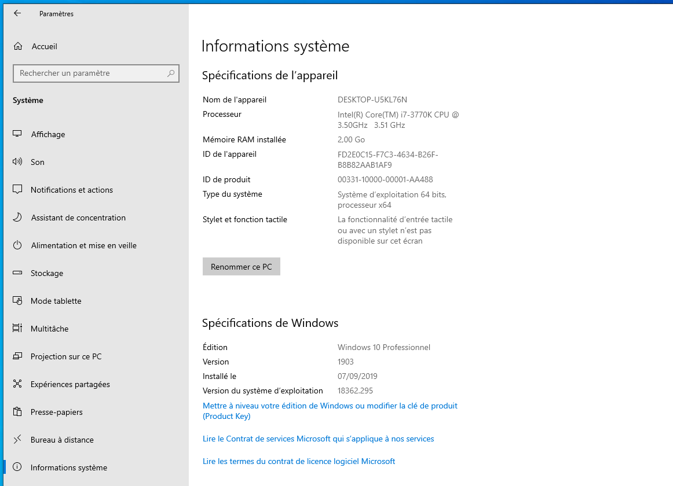

https://www48.zippyshare.com/v/H3pMyvSD/file.html

www-kms.com password

https://blog.team-rcv.xyz/geek/comment-avoir-office-2019-gratuitement/
https://www.tutorielpro.com/2018/08/30/comment-cracker-windows-10-et-microsoft-office/
